Maximum flow minimum cut

1. Find a minimum cut and the maximum flow in the following networks

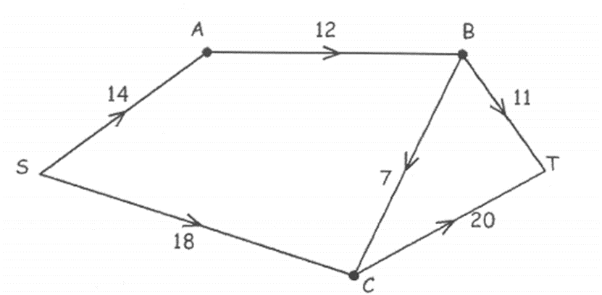



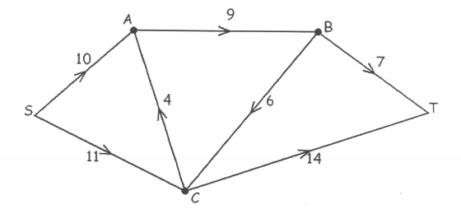

1. Find the maximum flow through the following networks and verify by finding the minimum cut.

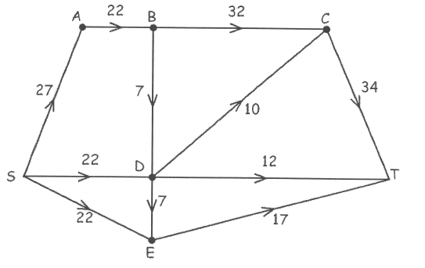



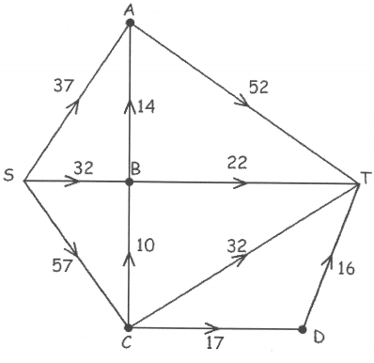

1. Find the maximum flow through the following network and a corresponding minimum cut.

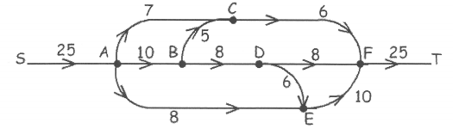

Identify how you could increase the maximum flow by 1 if you can change the capacity of one edge.

1. An oil company has a underground tank and wishes to transport its product to a tanker truck. The capacities of the various routes through pipes are shown in the diagram below.

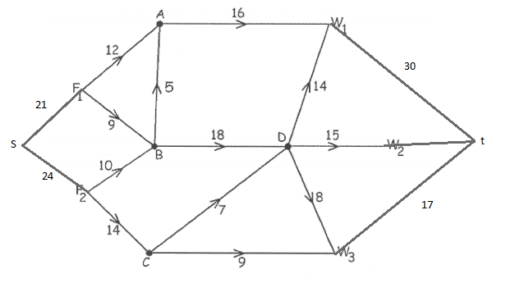

1. Find the maximum number of units of oil that can be transported through the network and determine if the demand of 40 units can be met.
   1. Verify by finding the minimum cut
   2. What is the outflow of the source?